**What is Round-Robin Scheduling?**

The name of this algorithm comes from the round-robin principle, where each person gets an equal share of something in turns. It is the oldest, simplest scheduling algorithm, which is mostly used for multitasking.

In Round-robin scheduling, each ready task runs turn by turn only in a cyclic queue for a limited time slice. This algorithm also offers starvation free execution of processes.

**Characteristics of Round-Robin Scheduling**

Here are the important characteristics of Round-Robin Scheduling:

* Round robin is a pre-emptive algorithm
* The CPU is shifted to the next process after fixed interval time, which is called time quantum/time slice.
* The process that is preempted is added to the end of the queue.
* Round robin is a hybrid model which is clock-driven
* Time slice should be minimum, which is assigned for a specific task that needs to be processed. However, it may differ OS to OS.
* It is a real time algorithm which responds to the event within a specific time limit.
* Round robin is one of the oldest, fairest, and easiest algorithm.
* Widely used scheduling method in traditional OS.

**Example of Round-robin Scheduling**

Consider this following three processes

| **Process Queue** | **Burst time** |
| --- | --- |
| P1 | 4 |
| P2 | 3 |
| P3 | 5 |

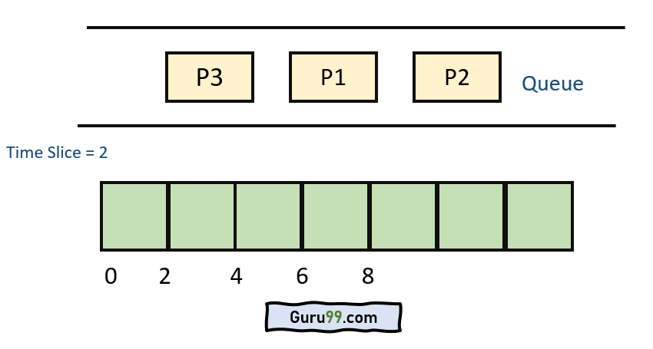

**Step 1)** The execution begins with process P1, which has burst time 4. Here, every process executes for 2 seconds. P2 and P3 are still in the waiting queue.

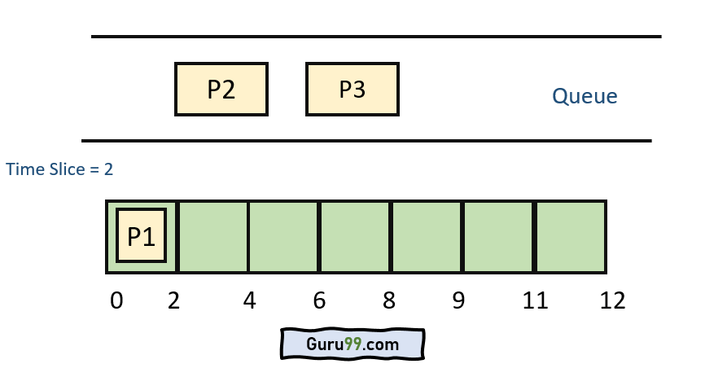

**Step 2**) At time =2, P1 is added to the end of the Queue and P2 starts executing

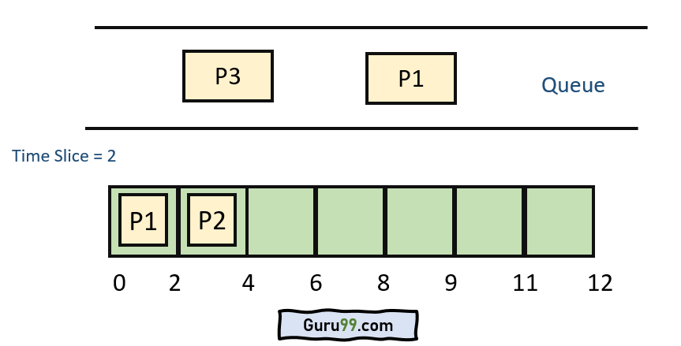

**Step 3)** At time=4 , P2 is preempted and add at the end of the queue. P3 starts executing.

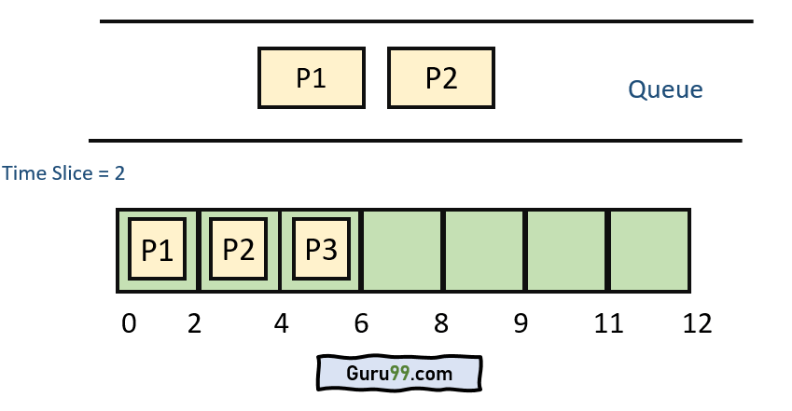

**Step 4)** At time=6 , P3 is preempted and add at the end of the queue. P1 starts executing.

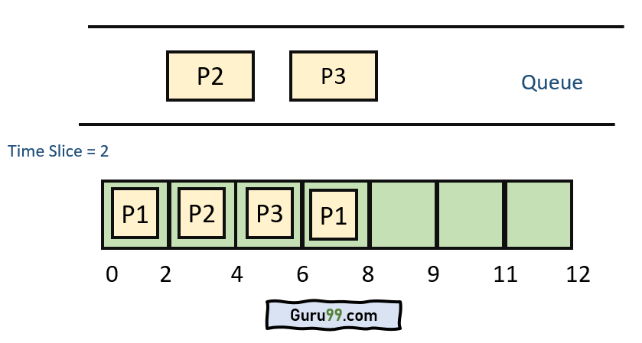

**Step 5)** At time=8 , P1 has a burst time of 4. It has completed execution. P2 starts execution

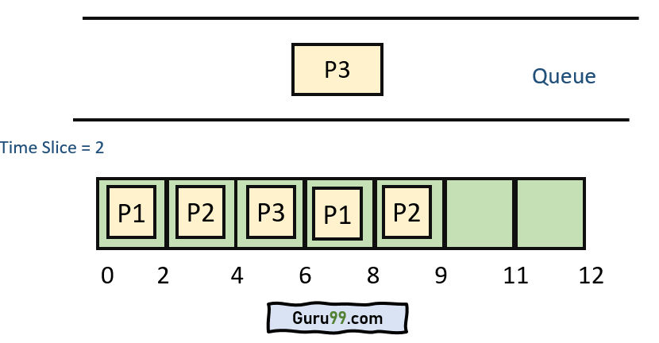

**Step 6)** P2 has a burst time of 3. It has already executed for 2 interval. At time=9, P2 completes execution. Then, P3 starts execution till it completes.

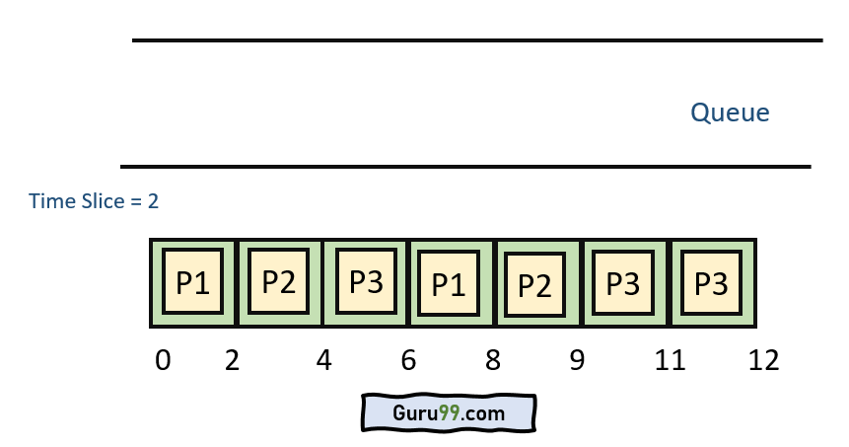

**Step 7)**Let’s calculate the average waiting time for above example.

Wait time

P1= 0+ 4= 4

P2= 2+4= 6

P3= 4+3= 7

**Advantage of Round-robin Scheduling**

Here, are pros/benefits of Round-robin scheduling method:

* It doesn’t face the issues of starvation or convoy effect.
* All the jobs get a fair allocation of CPU.
* It deals with all process without any priority
* If you know the total number of processes on the run queue, then you can also assume the worst-case response time for the same process.
* This scheduling method does not depend upon burst time. That’s why it is easily implementable on the system.
* Once a process is executed for a specific set of the period, the process is preempted, and another process executes for that given time period.
* Allows OS to use the Context switching method to save states of preempted processes.
* It gives the best performance in terms of average response time.

**Disadvantages of Round-robin Scheduling**

Here, are drawbacks/cons of using Round-robin scheduling:

* If slicing time of OS is low, the processor output will be reduced.
* This method spends more time on context switching
* Its performance heavily depends on time quantum.
* Priorities cannot be set for the processes.
* Round-robin scheduling doesn’t give special priority to more important tasks.
* Decreases comprehension
* Lower time quantum results in higher the context switching overhead in the system.
* Finding a correct time quantum is a quite difficult task in this system.

**Worst Case Latency**

This term is used for the maximum time taken for execution of all the tasks.

* dt = Denote detection time when a task is brought into the list
* st = Denote switching time from one task to another
* et = Denote task execution time

**Formula:**

Tworst = {(dti+ sti + eti ), + (dti+ sti + eti )2 +...+ (dti+ sti + eti )N., + (dti+ sti + eti + eti) N} + tISR

t,SR = sum of all execution times

**Summary:**

* The name of this algorithm comes from the round-robin principle, where each person gets an equal share of something in turns.
* Round robin is one of the oldest, fairest, and easiest algorithms and widely used scheduling methods in traditional OS.
* Round robin is a pre-emptive algorithm
* The biggest advantage of the round-robin scheduling method is that If you know the total number of processes on the run queue, then you can also assume the worst-case response time for the same process.
* This method spends more time on context switching
* Worst-case latency is a term used for the maximum time taken for the execution of all the tasks